The Mentee Handbook:

A Guide by the Havird Lab

Welcome to the Havird Lab!

As a new member of the lab, there are a few things we’ll need you to complete to comply with University policy and to help the lab get to know you better. This document will walk you through what tasks you should complete during your first few weeks in the lab. Please make a copy of this document and check off items as you go. If you have any questions about any of the items, please feel free to reach out to your mentor for assistance!

# Onboarding Tasks

* Add your Name, Email, and EID to [Mentee Information Sheet](https://docs.google.com/spreadsheets/d/111-eJec4S6y6lVmwSuz-j3oYMwrd4Zjxw-n0SXRkJ68/edit?usp=sharing)
* All the blanks next to your name in this google sheet should be filled in by the time you finish all the onboarding tasks. This document will assist you in completing these tasks.
* Complete the [Undergraduate Mentoring Plan](https://docs.google.com/document/d/1dJIrO5zZDeJQdZTqrREKwvESHuYGbdOpL9tafD-2POg/edit?usp=sharing)
* Please make a copy of this document, fill it out, then send it to your mentor to complete their half.
* Schedule a brief meeting with your mentor to discuss the document in person after you’ve both completed it.
* Complete Online Training Courses:
  + [OH 201 Laboratory Safety](https://utexas.csod.com/ui/lms-learning-details/app/course/c4aedcec-1b80-4d8d-8a7a-a7ea4ef11e57)
  + [OH 202 Hazardous Waste Management](https://utexas.csod.com/ui/lms-learning-details/app/course/4e3b9e29-ddc6-43d0-ac82-43a9476c8562#t=1)
  + [205 Portable Fire Extinguisher Basics](https://utexas.csod.com/ui/lms-learning-details/app/course/c37f4918-b5fc-4ead-8bf5-6d7889e9162e#t=1)
* Schedule an onboarding/introductory meeting with Justin Havird: [jhavird@utexas.edu](mailto:jhavird@utexas.edu)
  + Schedule & complete a lab safety training with Justin
  + Send a headshot and a short blurb about yourself to Justin to add to the website
* Provide 1. your graduating class year and 2. your research interests.
* Take a look at the current website to see what kind of information you can include in your blurb: <https://sites.cns.utexas.edu/havird/people-0>
* Decide whether or not to sign up for Course Credit with your mentor.
* Why should you get course credit? If you complete 3+ course credit hours doing research, it can count towards a biology elective course. It can make your course load lighter and we highly recommend everyone apply.
* Grading for course credit:

### How to Apply for Course Credit:

* Go to <https://cns.utexas.edu/biosciences-advising-center/research-credit> and select the discipline that best represents your degree or interests: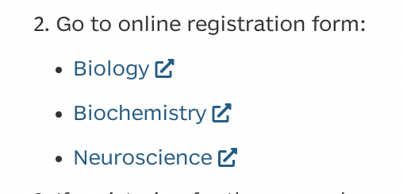
* Once you’ve chosen your discipline, click the orange arrow in the bottom right corner. Fill out the first page
* Discuss with your mentor how many credit hours to sign up for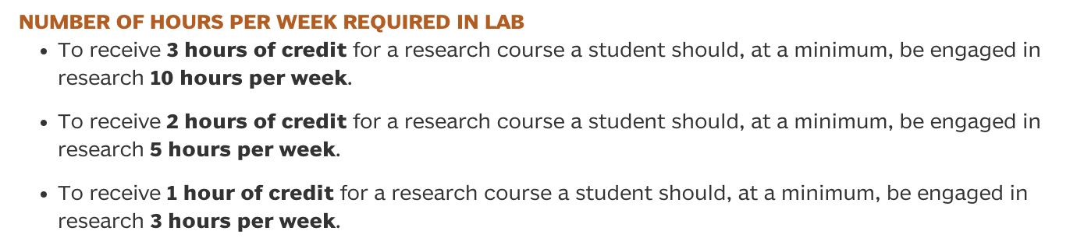
* Select the course that matches your course credit hour: Bio 177= 1 credit hour, Bio 277= 2 credit hours, Bio 377= 3 credit hours.
* Add Emergency Contact information to [Havird Lab Emergency Contacts](https://docs.google.com/spreadsheets/d/1Ait_VNTTxMQv2p3C8ijJqdnQtV6ayp6yDo8X1Jo_5aM/edit?usp=sharing) 
* Add the remaining items to the original spreadsheet: [Mentee_Information_Sheet](https://docs.google.com/spreadsheets/d/111-eJec4S6y6lVmwSuz-j3oYMwrd4Zjxw-n0SXRkJ68/edit?usp=sharing)
  + Project Topic/Title
  + Independent: are you doing an independent research project?
  + Affiliation: are you a volunteer for Justin’s lab, another lab, or a program such as a fellowship or internship? List all that apply & include the name of other PI’s or programs to which you belong
  + Start date
  + Prospective end date, when do you expect to leave the lab?